**CHAROTAR UNIVERSITY OF SCIENCE AND TECHNOLOGY**

|  |  |  |  |  |  |
| --- | --- | --- | --- | --- | --- |
| **DEVANG PATEL INSTITUTE OF ADVANCE TECHNOLOGY AND RESEARCH** | | | | | |
| **Department of Computer Engineering** | | | | | |
| **Student ID** | : | 18DCS007 | **Student Name** | : | RUDRA BARAD |
| **Subject Code** | : | CE442 | **Subject Name** | : | Design of Language Processors |
| **Date of exam** | : | 18/11/2021 |  |  |  |

**Definition:**

Implementation of Context Free Grammar.

**Program:**

#include<stdio.h>

#include<string.h>

#include<conio.h>

int i,j,k,l,m,n=0,o,p,nv,z=0,t,x=0;

char str[10],temp[20],temp2[20],temp3[20];

struct prod

{

char lhs[10],rhs[10][10];

int n;

}pro[10];

void findter()

{

for(k=0;k<n;k++)

{

if(temp[i]==pro[k].lhs[0])

{

for(t=0;t<pro[k].n;t++)

{

for(l=0;l<20;l++)

temp2[l]='\0';

for(l=i+1;l<strlen(temp);l++)

temp2[l-i-1]=temp[l];

for(l=i;l<20;l++)

temp[l]='\0';

for(l=0;l<strlen(pro[k].rhs[t]);l++)

temp[i+l]=pro[k].rhs[t][l];

strcat(temp,temp2);

if(str[i]==temp[i])

return;

else if(str[i]!=temp[i] && temp[i]>=65 && temp[i]<=90)

break;

}

break;

}

}

if(temp[i]>=65 && temp[i]<=90)

findter();

}

int main()

{

FILE *f;

// clrscr();

for(i=0;i<10;i++)

pro[i].n=0;

f=fopen("syntax.txt","r");

while(!feof(f))

{

fscanf(f,"%s",pro[n].lhs);

if(n>0)

{

if( strcmp(pro[n].lhs,pro[n-1].lhs) == 0 )

{

pro[n].lhs[0]='\0';

fscanf(f,"%s",pro[n-1].rhs[pro[n-1].n]);

pro[n-1].n++;

continue;

}

}

fscanf(f,"%s",pro[n].rhs[pro[n].n]);

pro[n].n++;

n++;

}

n--;

printf("\n\nTHE GRAMMAR IS AS FOLLOWS\n\n");

for(i=0;i<n;i++)

for(j=0;j<pro[i].n;j++)

printf("%s -> %s\n",pro[i].lhs,pro[i].rhs[j]);

while(1)

{

for(l=0;l<10;l++)

str[0]=NULL;

printf("\n\nENTER ANY STRING ( 0 for EXIT ) : ");

scanf("%s",str);

if(str[0]=='0')

printf("Exit");

// exit(1);

for(j=0;j<pro[0].n;j++)

{

for(l=0;l<20;l++)

temp[l]=NULL;

strcpy(temp,pro[0].rhs[j]);

m=0;

for(i=0;i<strlen(str);i++)

{

if(str[i]==temp[i])

m++;

else if(str[i]!=temp[i] && temp[i]>=65 && temp[i]<=90)

{

findter();

if(str[i]==temp[i])

m++;

}

else if( str[i]!=temp[i] && (temp[i]<65 || temp[i]>90) )

break;

}

if(m==strlen(str) && strlen(str)==strlen(temp))

{

printf("\n\nTHE STRING can be PARSED !!!");

break;

}

}

if(j==pro[0].n)

printf("\n\nTHE STRING can NOT be PARSED !!!");

}

getch();

}

**Content In “syntax.txt”:**

S aBaA

S AB

A Bc

B c

**Output Screen Shot:**

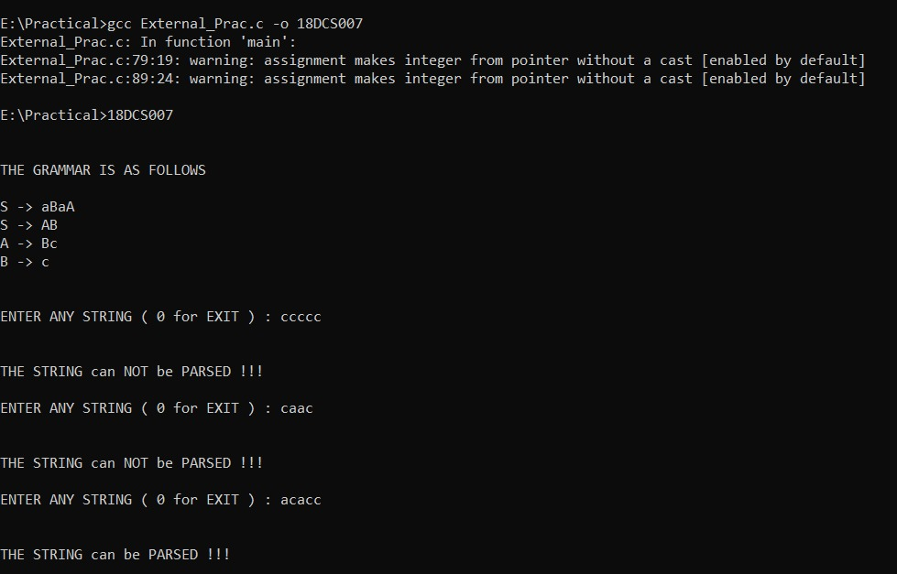

**Conclusion:**

Successfully completed Context Free Grammar Practical